
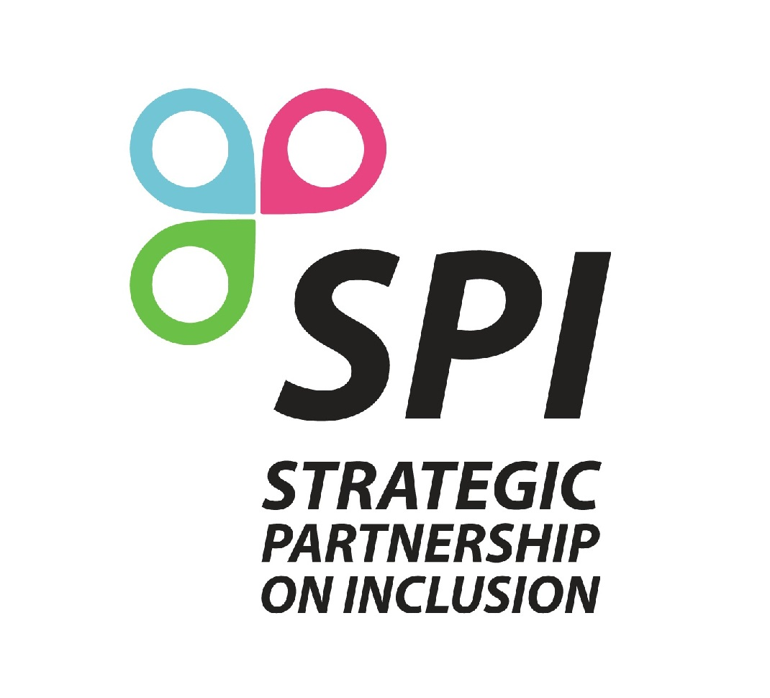
Strategic Partnership on Inclusion
Erasmus+ in Rural Areas

-International Project Lab-

14th-18th of March 2017, Portugal

Registration Form

1. Participant
Name: |  | Telephone:
Position: |  | Fax:
Address: |  | Email:
Address: |  | Country:
Address: |  | Gender: | Female Male
Professional Field: School, VET, Adult, Youth | (specify here the professional field selected)

2. Institution
Name: |  | Telephone:
Address: |  | Fax:
Country: |  | Email:
Legal representative: (Mr./Mrs.) |  | Type of Institution:

3. Language Skills

Please evaluate your English skills using the self-assessment tool – European language passport

English | Reading | Listening | Speaking | Writing
English | Please indicate your level (from A1 to C2)-here - | Please indicate your level (from A1 to C2)-here- | Please indicate your level (from A1 to C2)-here- | Please indicate your level (from A1 to C2)-here-

4. Experience

Please describe briefly your previous experience in rural area field (types of projects, target group, objectives and activities, partner countries).

Please describe briefly the activities of your organisation. Give examples

5. Motivation

Please, specify your main interest areas. You may propose themes regarding your ideas of future inclusion projects in rural areas under Key action 1 and/or 2.

6. Practicalities
Please complete these questions, so we can guarantee a smooth preparation, implementation, and follow-up of the seminar.
Do you have any special needs or requirements that the host National Agency should know about (e.g. medical needs, allergies, dietary restrictions, etc.)? Otherwise leave blank.

Emergency contact person. Please give name, phone number and e-mail of your emergency contact. Include the country code (e.g. +32 for Belgium).

Please take note of the following conditions that will apply if you are selected to take part in the Project Lab.
1. I commit myself to participate in the whole process, including: to prepare myself carefully for the training course; to do all remote preparation work the team will ask for; to take part in the full duration of the TC; to participate in the whole evaluation process.
2. I am aware that obtaining a health and a full travel insurance are my own responsibility and at my own expenses. I understand that the information I provided on my special needs does not remove my own personal responsibility for ensuring my own health.
3. I authorise my National Agency and the European Commission to publish, in whatever form and by whatever medium, including the Internet, my correspondence address, information about my organisation and work and pictures taken at the seminar.

Date Signature

